Lab Guide:

L751 - Adobe Target Search&Promote: Managing and promoting search results

Participant Number: __

Table of Contents

Lab Overview 4

Scope 4

Lesson 1—Logging into Search&Promote 5

Objectives 5

Logging in 5

Brief Primer: How does Search&Promote Work? 6

Lesson 2 – Understanding Built-in Search&Promote Reports 8

Objectives 8

What Reports are Available in Search&Promote 8

Search&Promote Reports 9

What should you pay attention to? 9

Lesson 3 – Previewing Site Search Results 12

Simulator Menu 12

Lesson 4 – Optimizing Failed Searches 14

Objectives 14

Creating Synonyms 14

Creating ‘Direct Hit’ Redirects 15

Settings for Handling Misspelling 16

Building an Autocomplete List of Suggested Search Terms 18

Creating ‘Banners’ to use in Search Results Pages 19

Lesson 5 – Optimizing for Long Tail Searches 20

Adjusting Relevancy Ranking Rules 20

Adjusting Weights by Field Values 21

Lesson 6 – Optimizing the Valuable Top Searches 23

Creating Business Rules 23

Previewing Business Rules in the Simulator Menu 25

Lesson 7 – Tips & Tricks 27

Relevancy, Relevancy, Relevancy 27

Indexing relevant content 27

Query Parameters 27

Additional Resources 28

Adobe Target Search&Promote 28

# Lab Overview

## Scope

In this training you will learn how to Optimize Site Search KPIs using Adobe Search&Promote. Search&Promote is designed for anyone, from novice to expert, to quickly and easily optimize and fine-tune site search on any web site.

NOTE: At your workstation you should have a paper with your participant number, e.g. “01”. This number gets used for many purposes during the lab (e.g., for login credentials, your demo site url, etc.). Wherever you see “YOUR NUMBER” in this lab manual, replace it with your participant number.

# Lesson 1—Logging into Search&Promote

## Objectives

* Log into the Search&Promote admin UI
* Overview of User Interface

## Logging in

Go to <https://searchandpromote.omniture.com>

Log in using the following credentials:

* Username: bpeabody+YOURNUMBER@adobe.com
* Password: Summit2018

IMPORTANT: For today’s Lab, you are all being given full Admin access privileges to the same shared Search&Promote account. You are free to go anywhere in the UI, but please do not click the “Save” option in any menu, unless instructed to do so, as those changes will be global.

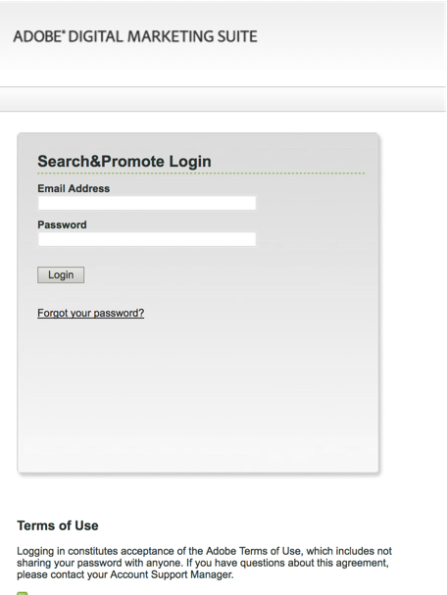

Figure : Adobe Search&Promote login page

## Brief Primer: How does Search&Promote Work?

Adobe Search&Promote is a cloud-based Software as a Service site search solution. Let’s just briefly examine how it works before diving into site search optimization strategies.

First, an index of your site is built. An index is a map of all the pages and words on your site. The index can be built by crawling your site with a spider, or through structured datafeeds of content that are passed to Search&Promote.

Navigate to ‘Settings > Crawling > URL Entrypoints’ to see where to plug-in urls to crawl within Search&Promote

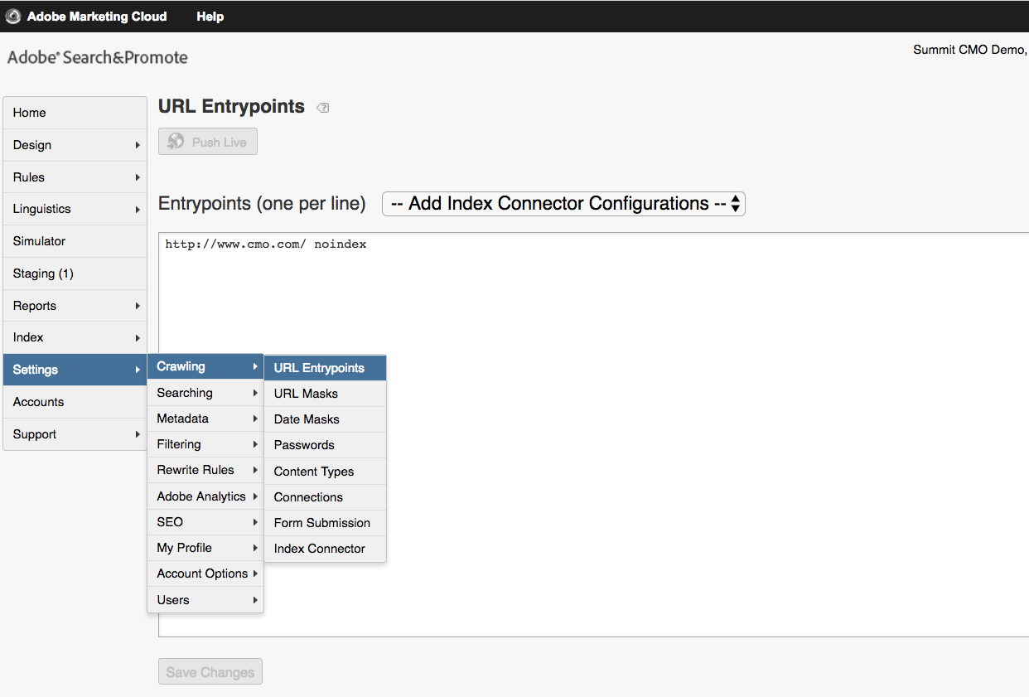

Figure 2: Settings > Crawling > URL Entrypoints menu

Next, Indexing is initiated under the Index menu options, and can be scheduled to occur at any interval to ensure that content added, or dropped, from your site is immediately reflected in the search index. We are going to skip running an index for this lab.

Once the Index is built, you can see the raw data under ‘Reports > Data Views > Default View’. Navigate to the Data View, and run some test searches. Today’s lab will use Index data from CMO.com, and will focus on how we can optimize these raw search results for site visitors. Note the different fields of information we will have to work with to configure relevancy.

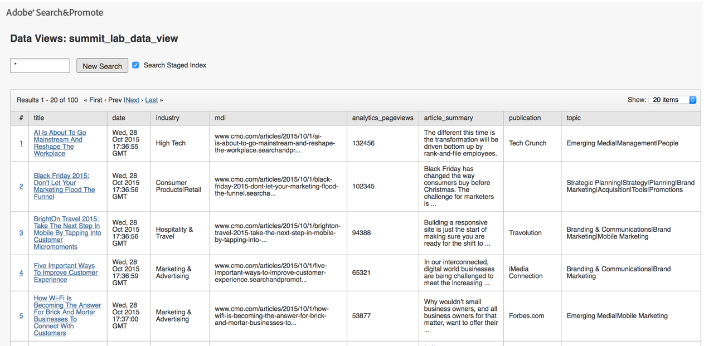

Figure 3: Reports > Data Views menu

# Lesson 2 – Understanding Built-in Search&Promote Reports

## Objectives

* Learn how to access Reporting within Search&Promote
* Understand key KPIs for your Optimization Efforts

## What Reports are Available in Search&Promote

Adobe Search&Promote is designed to report on only the top KPIs for understanding site search performance:

* Number of searches by date range
* Top search phrases and terms
* Failed search phrases and terms

Many more site search KPIs can be measured using Analytics. Analytics is required so that we can see the use of site search better in the context of the entire website. Key site search KPIs that can be measured in Analytics include:

* Search pathing & keyword pathing
* Use of internal search by page searched from
* Search term trending up/down
* Page is shown in results and lower placed page is clicked
* Search results page(s) abandonment
* Number of pages viewed before searching
* Use of refinements, sorting, next results clicks
* Sales revenue per keyword
* Exit rate by search keyword
* Search results rank value
* Calculated metrics like conversion rate for visitors using search versus not using search
* And many more (see appendix)…

In the time we have for today’s lab, we are going to focus on optimizing the top site search KPIs that you are likely already measuring: use of search, top searches and failed searches.

## Search&Promote Reports

From the left-hand menu in Search&Promote, navigate to ‘Reports > Terms Report’. Build a report based on either words or phrases, for a day, week, or month range.



Figure 4: Reports > Terms Report – showing Valuable Top terms.

The columns show search term, number of results returned for that search term, and the number of times the term was searched. Clicking on the hyperlinked search term shows the actual search results returned for each term.

Note that reports can be downloaded as a csv file for deeper analysis in a spreadsheet.

## What should you pay attention to?

**Top Searches**

Analyze top searches report to determine the “Valuable Top” search terms, and to survey the “Long Tail” – unique terms that are searched far less often. The Valuable Top will be your most frequently searched terms (e.g. the top 50 common searches over time). In the chart below, the X-axis represents number of unique search terms, and the Y-axis represents % of time that term is searched. In this example, the same 100 search phrases are used 55% of the time.

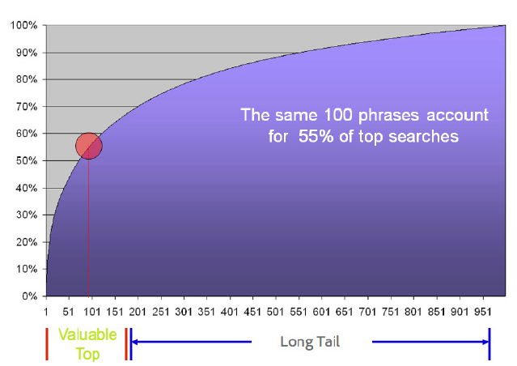

Figure 5: Valuable Top versus Long Tail queries

In today’s lab, we will focus on some strategies to optimize for both the Valuable Top and the Long Tail.

**Failed Searches**

Now navigate to ‘Reports > Null Search Term Report’ and examine the search terms that are yielding zero results on this site. If there are a lot of terms here, we will want to focus optimization efforts on the most frequently used failed search terms as a starting point. In this example for CMO.com, we may want to optimize against searches for “marketecture” but not bother with other irrelevant or less frequently searched failed search terms.



Figure 6 Reports > Null Searches report showing failed search terms

**Number of Searches Performed**

Navigate to ‘Reports > Search Request Reports’. Here you can see the number of searches performed against the search index over a given time period. You can expand the report to show up to 3 years of data to better understand any seasonal trends in searching on your site. Using site Analytics data, you can also get a sense of the percentage of visitors using site search, and whether usage is increasing or decreasing. Lastly, this report will quickly alert you to any problems if site search use suddenly spikes or diminishes for some reason.

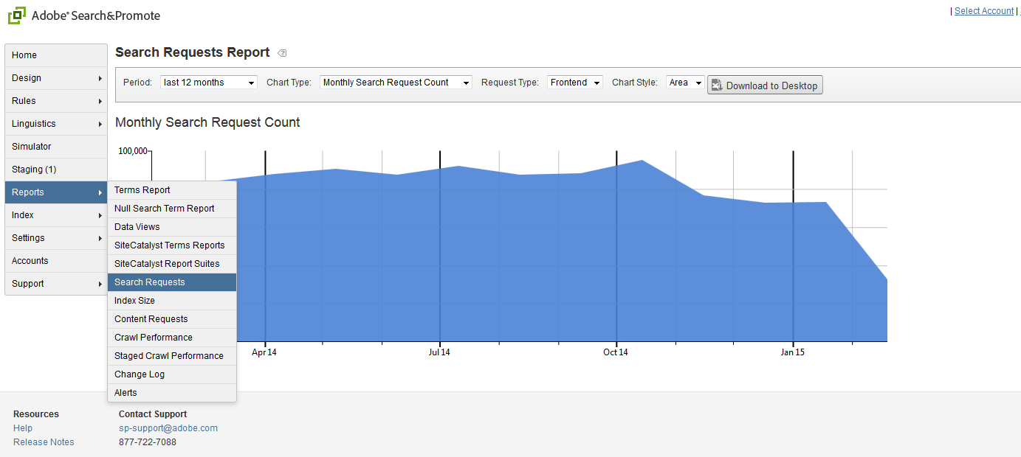

Figure 7: Reports > Search Requests menu showing total number of searches by date range.

# Lesson 3 – Previewing Site Search Results

In today’s Lab we will be optimizing site search results and it will be important to preview any of those changes within the tool.

## Simulator Menu

Select “Simulator” in the left-hand navigation. The Simulator acts as a built in staging environment within Search&Promote and would mirror the look and feel of the client website. Any changes that you make to relevancy, synonyms, etc. settings within Search&Promote can be previewed and QA tested before pushing to a live production environment. Try running some searches on some of the top or failed search terms that were indicated in the Reports menu. As we optimize search results, we will revisit the Simulator page to preview any adjustments.

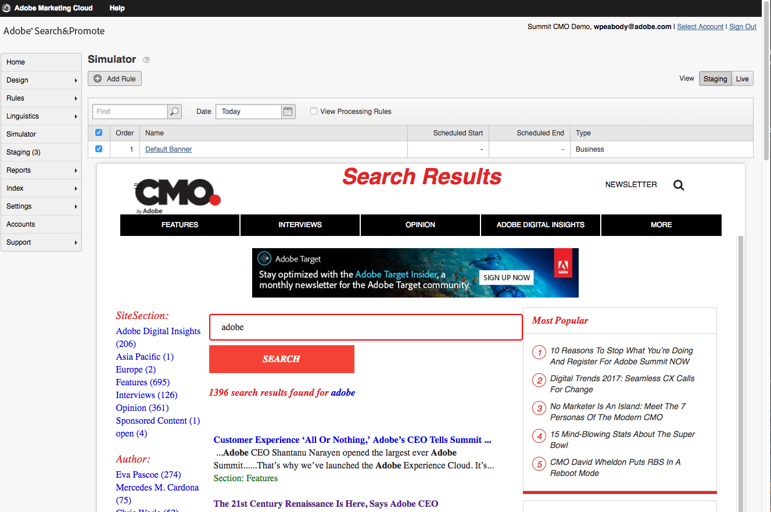 Figure 8: The Search&Promote Simulator menu

# Lesson 4 – Optimizing Failed Searches

## Objectives

* Learn how to create Synonyms & Hyponyms
* Create ‘Direct Hit’ redirects for search terms
* Handle misspelling settings & options
* Building Auto-complete predictive search lists
* Creating best-bet Banners to use in search results

## Creating Synonyms

In the Simulator menu, try running a search for your last name. You should see a failed search (search with zero results) unless your name happens to be in the CMO.com index. Let’s create a new Synonym to optimize that failed search experience.

Navigate to the ‘Linguistics > Dictionaries’ menu and choose to ‘Edit’ (in right rail) the Synonyms dictionary. You should see the menu shown below.

Figure 9: Linguistics > Dictionaries menu to configure synonyms

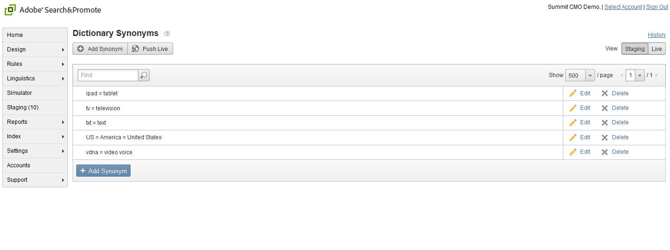

Creating a new synonym is easy, just click “Add Synonym” and, in the dialog box, associate terms together using an equals (=) sign. For example car=automobile=auto. Try creating a synonym for your last name with the term ‘cmo’ (e.g. lastname=cmo). Once everyone has done that we will refresh the index and return to the Simulator menu later on to test the quick change to fix the failed search on your name.

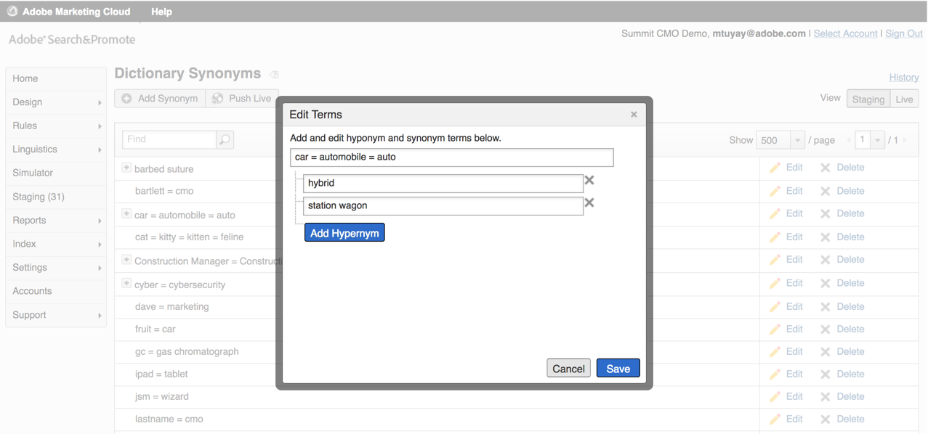

Figure : Creating synonyms and hyponyms

**What’s a hyponym and a hypernym?** A hyponym is a word or phrase that shares a *type-of* relationship with its hypernym. For example, *pigeon, crow, eagle* and *seagull* are all hyponyms of *bird* (their hypernym).

## Creating ‘Direct Hit’ Redirects

Under the ‘Rules > Direct Hits’ menu, redirects can easily be set-up per search term or range of terms. The format is simply: url: search term(s). So, for example, if you wanted to redirect queries for “faq” to your support page instead of a failed search page, the format would be ”<http://www.mycompany.com/support.html>: faq”

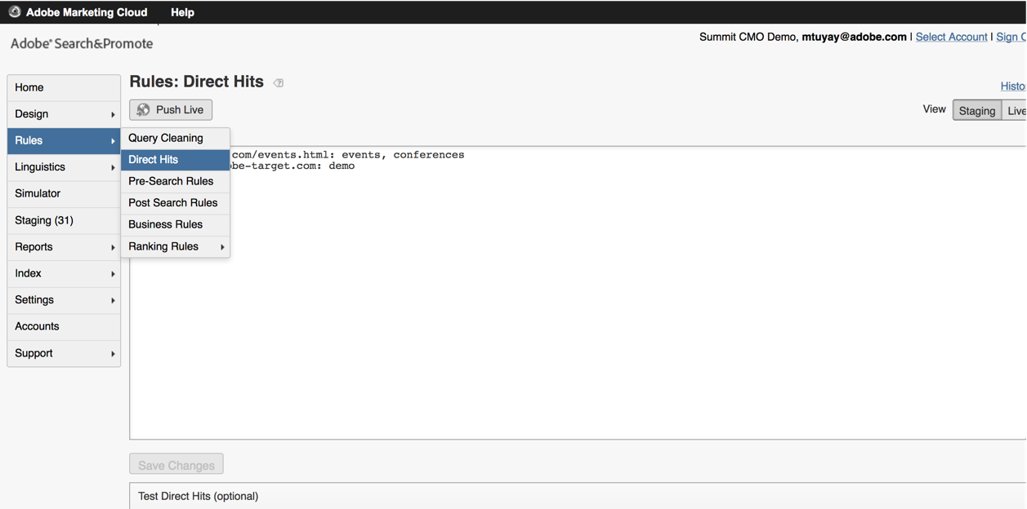

Figure 11: Rules > Direct Hits menu for configuring redirects based on query term

## Settings for Handling Misspelling

There are a number of Linguistics settings that can be controlled via the interface. Please examine some of the other menu choices under the **Linguistics** tab to see the different options supported. **Words&Languages** allows for global configurations of language settings (e.g. supporting case sensitive search). **Excluded Words** allows the creation of a stop-word list, words that shouldn’t be used in a search even if entered in the search box. And **Common Phrases** allows for logical groupings of words in a search phrase (e.g. if ‘short’ and ‘sleeve’ are searched together, treat as phrase ‘short sleeve’).

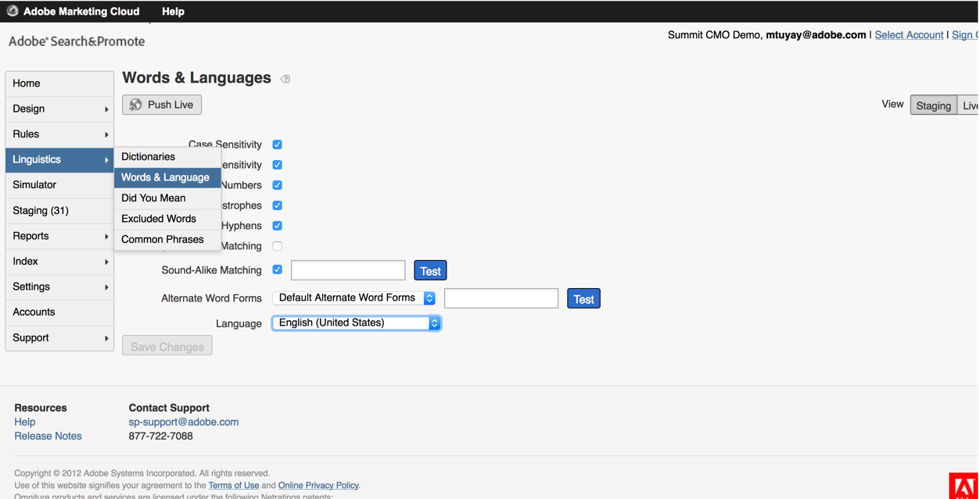

Figure 12: Linguistics > Words & Language menu

## Building an Autocomplete List of Suggested Search Terms

Another good method for alleviating failed searches due to misspellings on your site is via the use of predictive search. Please navigate to Design > Auto-Complete > Word List and we will walk through the options for configuring type-ahead searching.

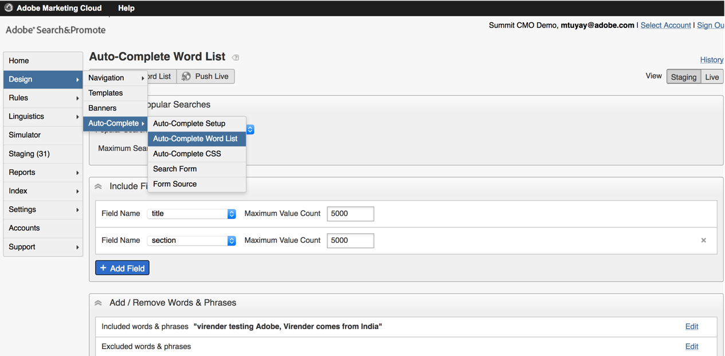

Figure 13: Design > Auto-Complete menu items and configuration

## Creating ‘Banners’ to use in Search Results Pages

Please navigate to the Design > Banners menu where we will discuss how to create promotional ‘Banners’ that can be injected into results pages using Business Rules. We will cover building Business Rules later in the Lab. Mouse-over the “Adobe Summit Banner” and choose the “Edit” option to examine how banners are created.

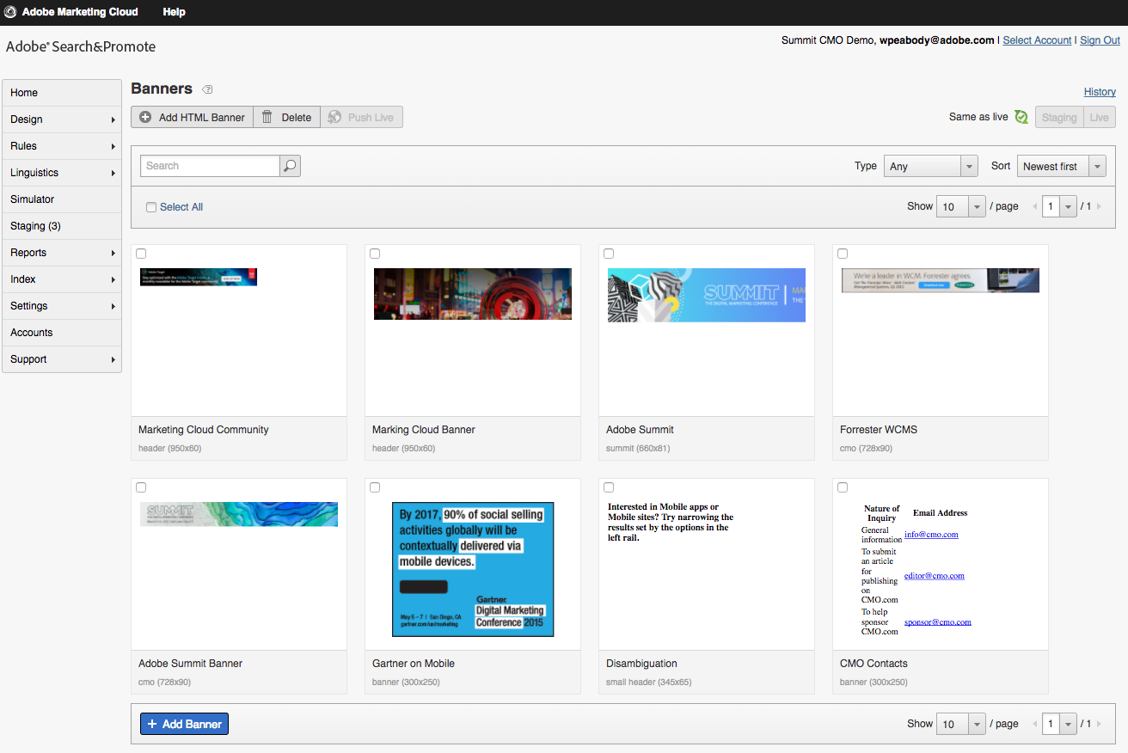

Figure 4: Design > Banners menu

# Lesson 5 – Optimizing for Long Tail Searches

In Lesson 4 we learned how to optimize for specific search terms. But what about the long-tail searches? We can’t build rules for tens of thousands of search terms. For optimizing ‘every other search’ on your site, you need to rely on the site search relevancy ranking algorithm. In this lesson, we will learn about configuring Relevancy in Search&Promote.

## Adjusting Relevancy Ranking Rules

Please select “Rules > Ranking Rules > Adjust Weights” in the left hand navigation. Do you recall the “Reports > Data Views” menu we looked at to determine what is in the search index? Ranking Rules now allow us to determine the importance of each field relative to each other. For example, the Page Title field is generally going to be very important whereas the URL field is not. Try playing the sliders on this page. Natural Relevance is the baseline (e.g. frequency keyword is found in title or body of a page). Rules allow you to add and blend additional meta field weightings to construct a custom Rule. Any number of custom Ranking Rules can be created and used for testing or targeting of results pages.

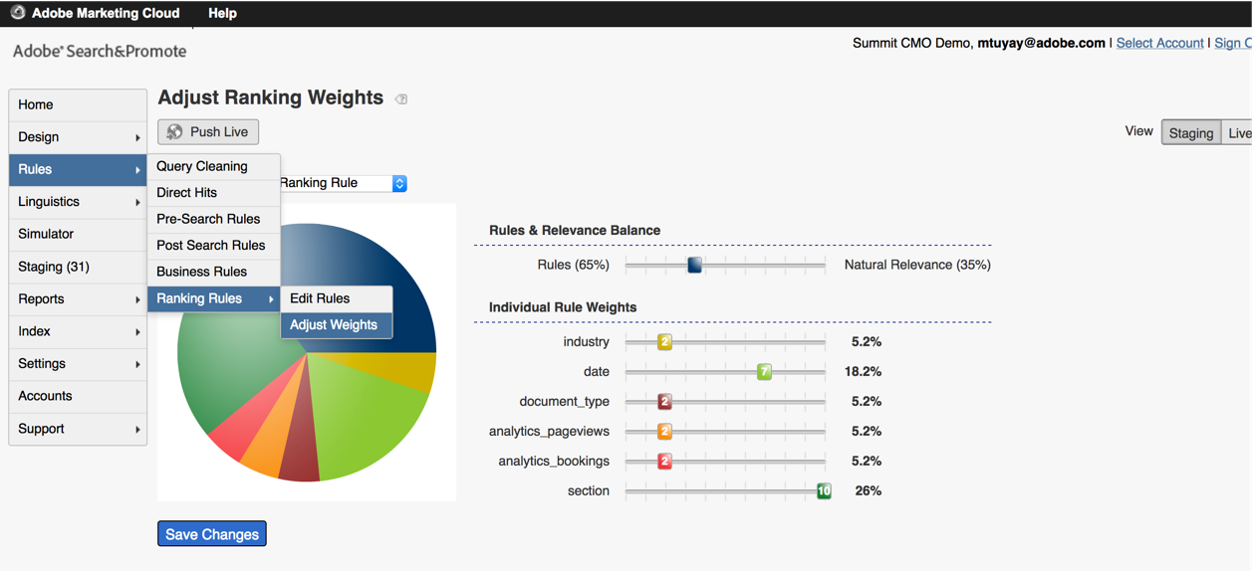

Figure 6: Rules > Ranking Rules > Adjust Weights menu

## Adjusting Weights by Field Values

If you look at the ‘Individual Rule Weights’ in the image above, you will see that the site “section” field has been given a higher weighting than the “industry” field. But your site has many sections, and you want to force Marketing content ahead of About-Us content on your site. We can adjust such meta field values under the ‘Rules > Ranking Rules > Edit Rules’ menu, please navigate to that menu.

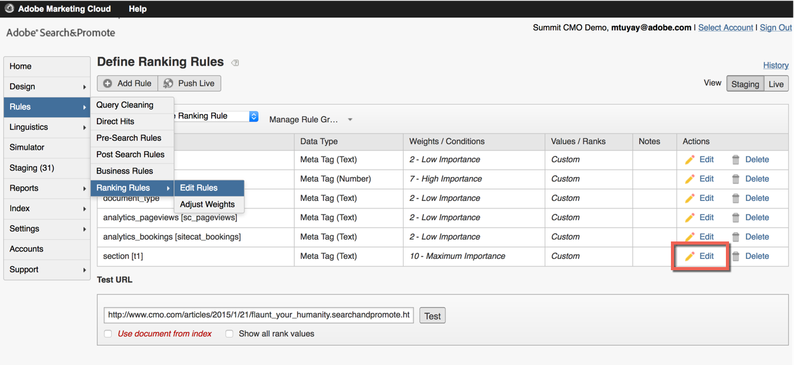

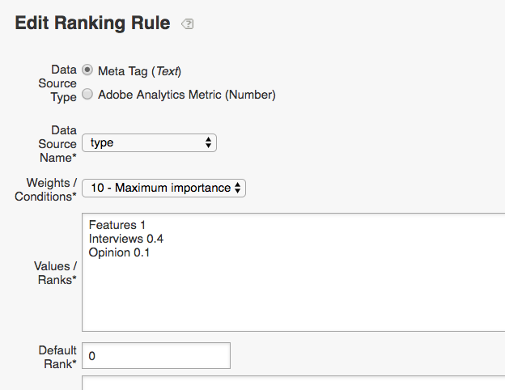

Figure 6: Rules > Ranking Rules > Edit Rules menu

Once there, please select “Edit” (right rail) for the “section” field. In the dialog box that opens, note how you can:

* Include any data source field in a ranking rule, including Analytics metrics like PV volume
* Set the weight of the data source field, relative to other fields, using a 0 to 10 scale
* Include and rank individual meta field values

In the “Values / Ranks” field, you can use a 1.0 to -1.0 scale to promote or demote, in this case, site section values. Insight, with a 1 value, is most important, with News after that; while About-Us, with a -1 value, is least important. If a search yields results in these sections that are roughly of equal Natural Relevance, they will be shown in the site section order specified here.

Please don’t ‘Save’ any changes, the instructor will make a change as an illustration for the lab.

# Lesson 6 – Optimizing the Valuable Top Searches

In lesson 5, we learned how to optimize Relevancy to handle all the possible searches in the long tail. Through Analytics however, you may determine that 60% of all your site searches use the same 50 search phrases, the “Valuable Top”. This is low-hanging fruit for optimization; take a look at the results you are delivering on the top search terms. There’s a good chance that they can be further optimized, and in this lesson we will learn how to use Business Rules to do so.

## Creating Business Rules

From the left hand navigation in Search&Promote, please return to the Simulator menu and then run a search within CMO.com for “mobile”. Let’s say that is one of our top search terms, and we want to optimize the results shown for that search term. Please click on “Add Rule” (upper left in UI) to launch the Business Rule Builder.

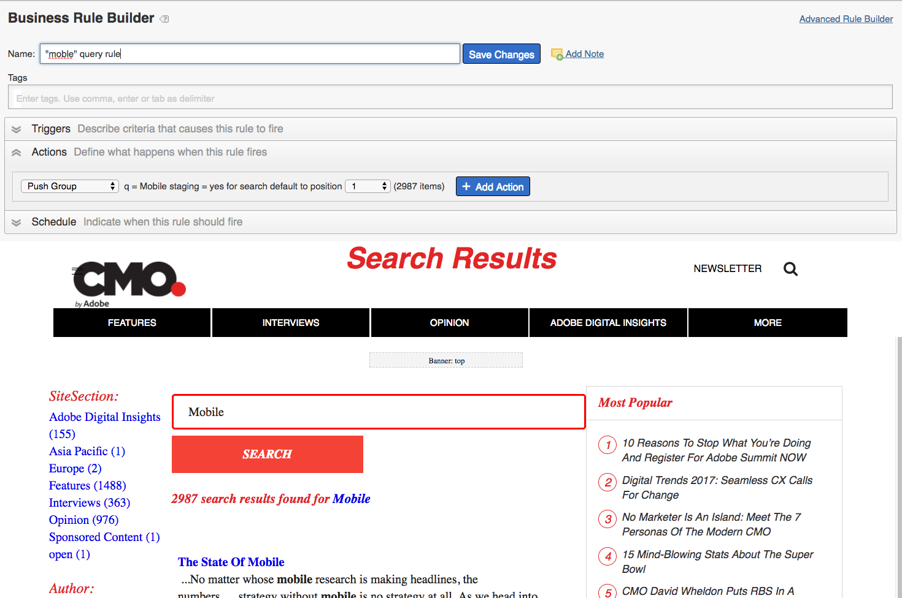

Figure17: The Business Rule Builder interface

Creating a Business Rule to customize the results presentation only takes a few minutes, even for a non-technical user. As you can see in the new window, the steps involved are:

* Giving your Business Rule a unique name (so you can see/understand all the rules firing in Simulator)
* Apply any taxonomical tags, used to manage many business rules better (optional)
* Set the “Trigger” – when should the rule fire
* Set the “Actions” – what do you want to happen after Trigger is fired (more below)
* Define the “Schedule” for the new Business Rule
* Apply the new Rule to a pre-defined Target campaign (optional)

Let’s look close at the “Actions” step. Select (or click) this Actions tab, and then scroll the window down to the results shown. Now right click on any of the results hyperlinks/titles. As you can see, you can override the default relevancy ranking algorithm for this search term by pushing individual search results up or down in rank, or remove or add results. Where you see a grey-shaded ‘Banner’ zone, you can right click and choose any of the Banners that we created previously. Any number of Banner zones can be created, and Facets can be controlled as well.

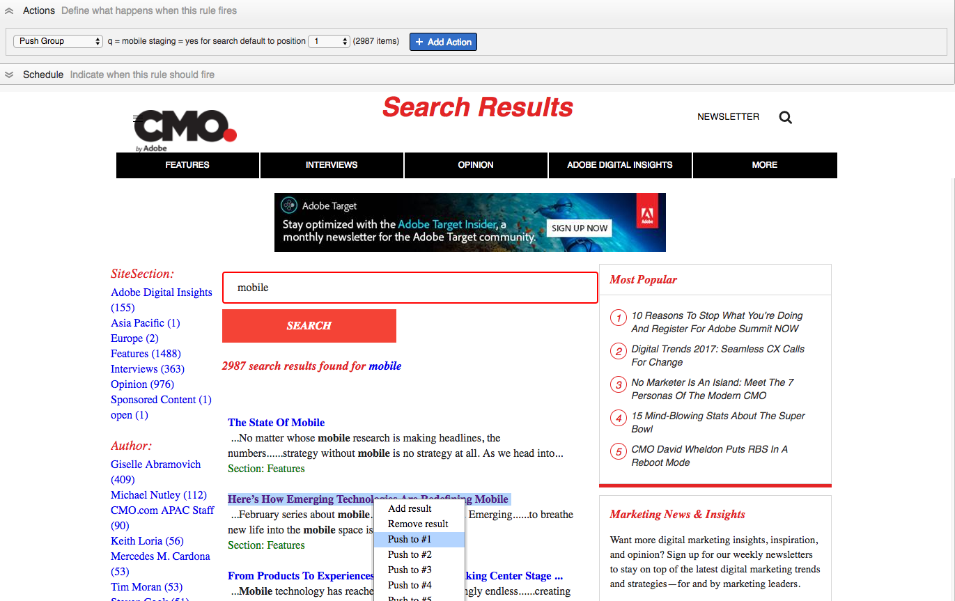

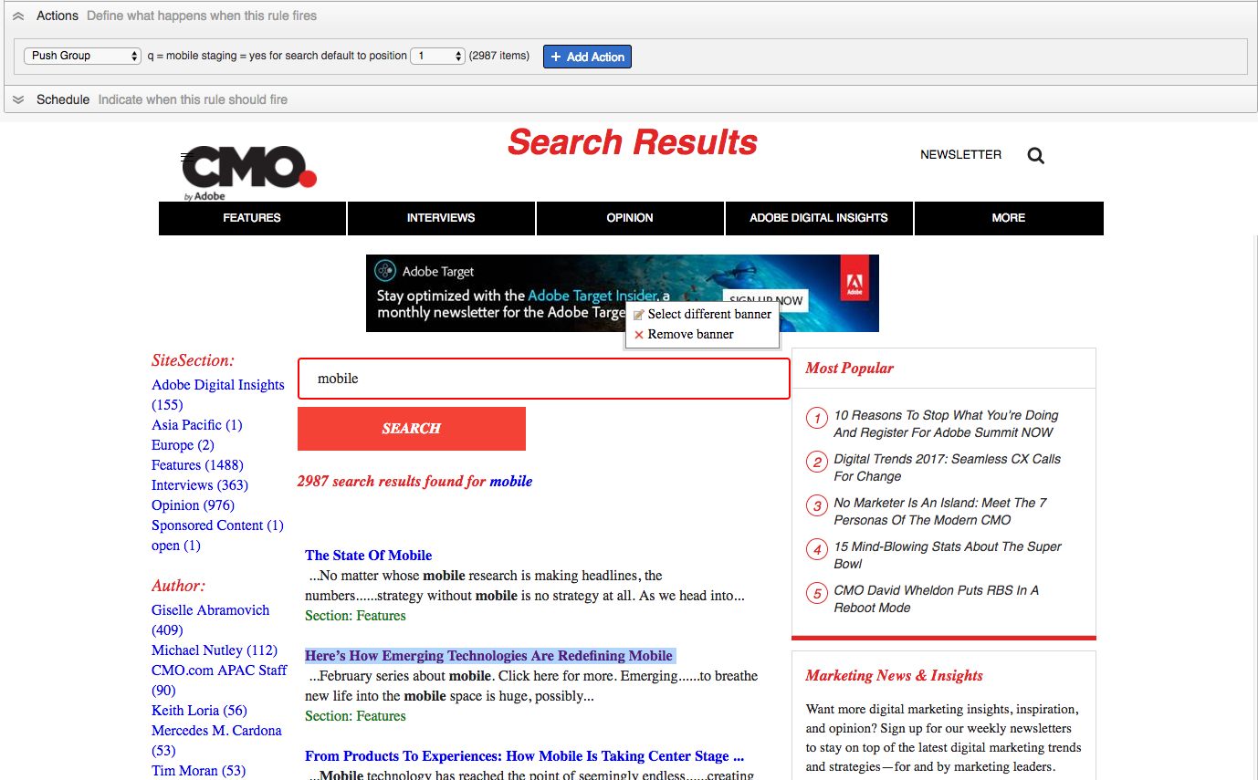

Figure 8: Setting Activities in WYSIWYG fashion within the Business Rule Builder

That’s it! Let’s return to the Simulator to see the change we quickly made for the Top Search keyword “mobile” on CMO.com. Since we don’t want to make 50 simultaneous rules on the same query, the instructor will save the Business Rule and present the change in the Simulator.

## Previewing Business Rules in the Simulator Menu

If we return to the Simulator menu (close out of the Business Rule Builder), please run the search for “mobile” once again. You should see the changes we quickly made to the results page for that query, and we can see the new Business Rule name indicated in the table above results. Try de-selecting the checkbox next to the rule name to see the before & after, this is useful for other team members to understand each rule. Only one rule is listed in today’s lab, but if multiple rules were firing for this query, they would all be indicated to understand any rule conflicts or re-prioritize the order in which rules fire.

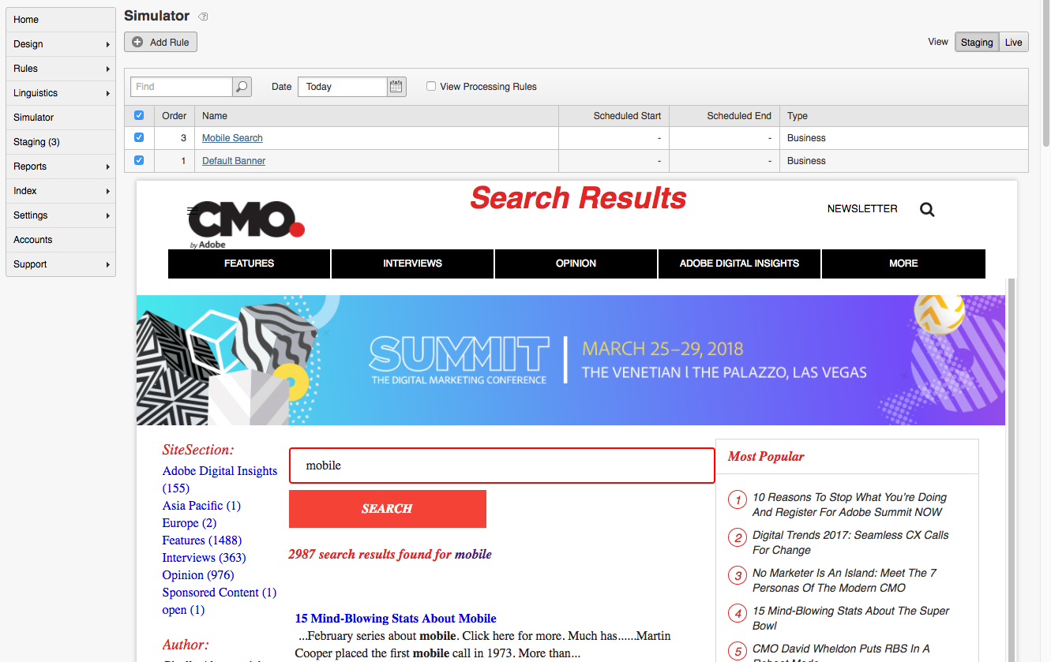

Figure 9: Preview Business Rules in the Simulator menu

# Lesson 7 – Tips & Tricks

## Relevancy, Relevancy, Relevancy

Due to continuously changing set of content being indexed, regularly occurring Quality of Search assessments and tuning are highly recommended.

* Qualitative review of the search results
* Typically, the top X terms and ‘pet’ terms are used in the assessment
* Top terms are defined differently in different organizations

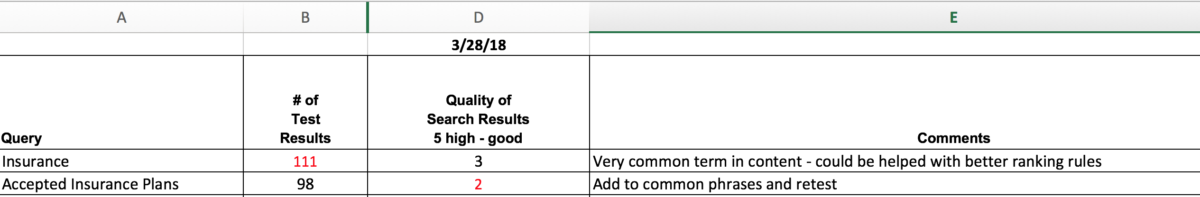

*\*\* After relevancy adjustments are made and pushed live, engagement \ conversion metrics should be used to confirm the validity of the QoS assessment and tuning effect*

## Indexing relevant content

During the crawling \ indexing process, by default, the entire html page is indexed. This includes headers, footers, navigation, side bars, etc. This can cause ‘noise’ that pollutes the search results.

To prevent parts of individual web pages from being searched, you can exclude portions of a page from indexing by surround the text with <noindex> and </noindex> tags. The recommended solution is to have these tags added to the source templates. There is a fall back solution of injecting the tags in Seach&Promote through Filtering Scripts.

## Query Parameters

You have control of many aspects of query behavior in Search&Promote. Full documentation for the parameters can be found in the Search&Promote help section listed in the resource section.

* Any, All or Exact: Specifies the default type of searching to perform. For example, sp_p - <http://sp1004ebf9.guided.ss-omtrdc.net/?q=Adobe%20Summit%202018&sp_p=any>
* Wildcard expansion: Specifies that automatic wildcard expansion should take place for any word from the query string with more than number characters. For example, sp_e=4 - <http://sp1004ebf9.guided.ss-omtrdc.net/?q=Adob&sp_e=4>
* Proximity Searching: Allow the users & content location to factor in to relevancy. For example, sp_q_location=88901

# Additional Resources

## Adobe Target Search&Promote

http://www.adobe.com/marketing-cloud/testing-targeting/search-driven-merchandising.html

**Adobe Target Search&Promote Training Course**

https://training.adobe.com/training/courses/adobe-target-site-search-and-merchandising.html

**Adobe Target Search&Promote Online Help Documentation**

https://marketing.adobe.com/resources/help/en_US/snp/

**Adobe Target Online Help Documentation**

https://marketing.adobe.com/resources/help/en_US/target/

**Adobe Target Community**

http://help-forums.adobe.com/content/adobeforums/en/target-forum/adobe-target.html

**Digital Marketing Blog: Financial Services Fundamentals: Internal Search**

http://blogs.adobe.com/digitalmarketing/digital-marketing/financial-services-fundamentals-internal-search-part-1/

**Digital Marketing Blog: Acting on Your Site Search Analytics**

http://blogs.adobe.com/digitalmarketing/analytics/acting-on-your-site-search-analytics/

**Digital Marketing Blog: Internal Search Tracking and a Few Best Practices**

http://blogs.adobe.com/digitalmarketing/analytics/internal-search-implementation-and-a-few-best-practices/

**Digital Marketing Blog: Mozy.com Site Search Success Story**

http://blogs.adobe.com/digitalmarketing/personalization/mozy-increases-customer-satisfaction-with-lower-support-costs-and-achives-100-roi-with-adobe/

**Kirkland Site Search Success Story**

http://apps.enterprise.adobe.com/go/701a0000002J8PEAA0